Course: MAI511-1 - Advanced Database Technologies
LAB Exercise – III Data Retrieval using JOINS, Subqueries and Correlated queries
Name: Vismitaa S
Register Number: 2648552
1. Write SQL statements to demonstrate the following JOIN operations on the tables created for your application domain. INNER, LEFT, RIGHT, and FULL OUTER JOINS. Specifications:
a. The Operations should be performed on tables with logical sense and mention valid justification.

- Inner Join
Scenario: Internship with Company

Justification: Shows internship details only when a matching company exists

Query:

Output:

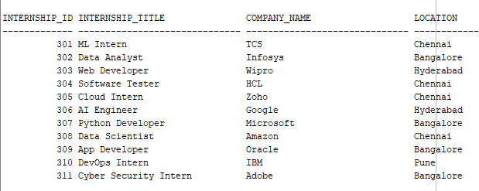

- Left join

Scenario: Display all students, including those who have not yet received an internship evaluation.

Justification: A LEFT JOIN returns rows from the left table (Students) and the matching rows from the right table (Intern_Evaluation). If no matching evaluation exists, displays NULL.

Query:

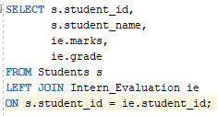
Output:

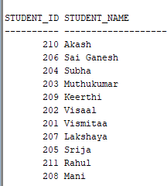

- Right Join

Scenario: Display all companies, including those that may not currently offer any internship

Justification: A RIGHT JOIN returns all rows from the right table (Company) and matching rows from the left table (Internship).

Query:

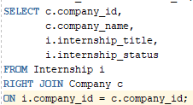

Output:

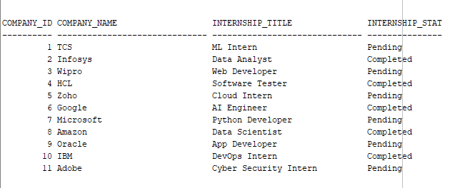

- Full Outer Join

Scenario: Display all records from both the Mentor and Internship tables

Justification: A FULL OUTER JOIN is appropriate because it retrieves all records from both the Mentor and Internship tables. If a mentor does not supervise any internship, the internship columns are displayed as NULL. Similarly, if an internship has no assigned mentor, the mentor columns are displayed as NULL

Query:

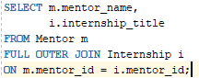

Output:

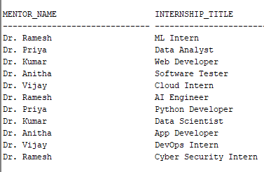

b. What is the difference between each JOIN?

- INNER → Matching only
- LEFT → Everything from the left table
- RIGHT → Everything from the right table
- FULL OUTER → Everything from both table

2. Demonstrate the usage of subqueries to implement the operations to be performed on the tables created for your application domain.

Specifications:
- At least 5 subqueries should be demonstrated.

- Company Located in Chennai

Query:

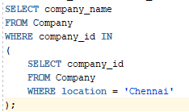

Output:

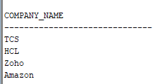

- Mentors Supervising Pending Internships

Query:

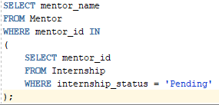

Output:

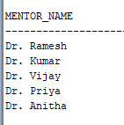

- Companies Offering Technology Internships

Query:

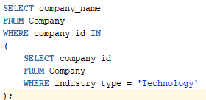

Output:

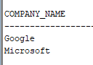

- Internship Starting After June 1, 2026

Query:

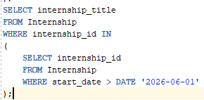

Output:

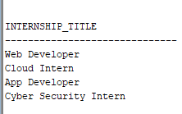

- Mentor Assigned to AI Engineer Internship

Query:

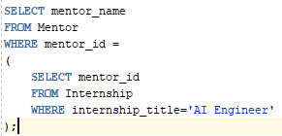

Output:

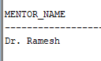

- All tables should be used in at least 1 Compound SQL Query to perform a specified operation.

Query:

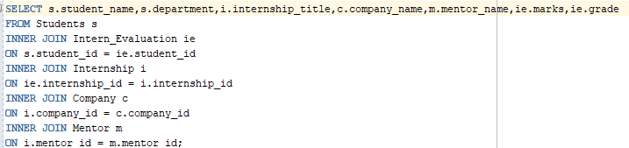

Output:

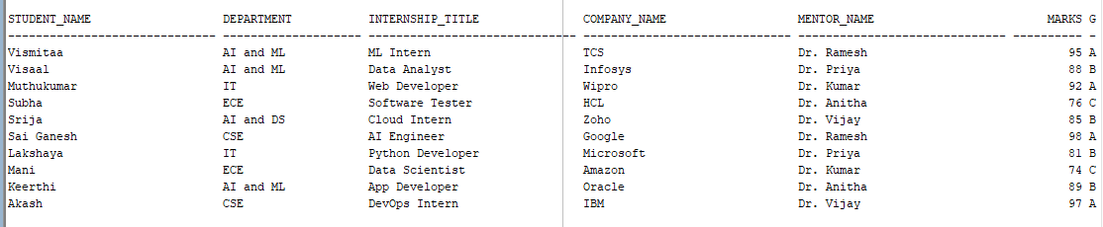
- The Operations should be performed on tables with logical sense and mention valid justification.

Scenario: Generate a complete internship report with student, internship, company, mentor, and evaluation details.
Justification: Combines all five tables to provide a comprehensive view of the internship management system.

